Title (14 pt., Upper and Lower Case, Bold and Centered)

One Enter (14 pt.)
Author 1 (12 pt., Upper and Lower Case, Bold and Centered)
Department (10 pt., Upper and Lower Case, Centered),
Organization, City, State, Country (10 pt., Upper and Lower Case, Centered).
E-mail: (10 pt., Upper and Lower Case, Centered)
One Enter (10 pt.)
Author 2 (12 pt., Upper and Lower Case, Bold and Centered)
Department (10 pt., Upper and Lower Case, Centered),
Organization, City, State, Country (10 pt., Upper and Lower Case, Centered).
E-mail: (10 pt., Upper and Lower Case, Centered)
One Enter (10 pt.)
Author 3 (12 pt., Upper and Lower Case, Bold and Centered)
Department (10 pt., Upper and Lower Case, Centered),
Organization, City, State, Country (10 pt., Upper and Lower Case, Centered).
Corresponding author: (10 pt., Upper and Lower Case, Centered)
One Enter (10 pt.)
Author 4 (12 pt., Upper and Lower Case, Bold and Centered)
Department (10 pt., Upper and Lower Case, Centered),
Organization, City, State, Country (10 pt., Upper and Lower Case, Centered).
E-mail: (10 pt., Upper and Lower Case, Centered)

(Received on; Accepted on) (9 pt.)
First Enter (9 pt.)
Second Enter (9 pt.)
Third Enter (9 pt.)

Abstract (Bold, left align)

Abstract text 75 words to 250 word (9 pt. justify).
One Enter (9 pt.)

Keywords- Number of keywords 3 to 5. (9 pt. justify).
First Enter (9 pt.)
Second Enter (9 pt.)
Third Enter (9 pt.)

1. Introduction (All Heading and Sub-Headings in 12 pt. Upper and Lower Case Bold and Justify)
All text between heading and sub-heading in 11 pt. and justify. Give enter of 11 pt. after each paragraph.
One Enter (11 pt.)
Paper Size: Letter, 8.5”X 11”; Top Margin: 1.5”; Bottom: 1”; Left: 1.5”; Right: 1.0”; Gutter: 0.0; Gutter Position: Left. Header and Footer: 0.6”.
One Enter (11 pt.)
Line Spacing: Single whole paper, Spacing: Before: 0 pt., After: 0 pt.
One Enter (11 pt.)
Whole paper should be written in Times New Roman fonts. Reference citation should be in APA style. All references should be given in the reference section in APA style also.
One Enter (11 pt.)
Mathematical equations should be written by using the inbuilt MS word equation editor with 11 pt. as given below
${\left(x+a\right)}^{n}=\sum_{k=0}^{n}{\left(\frac{n}{k}\right)x^{k}a^{n−k}}.$ (1)
One Enter (11 pt.)
Also, mathematical equations can be written by using Microsoft Equation 3.0 or Mathtype.
One Enter (11 pt.)

2. Second Heading (12 pt. Upper and Lower Case Bold and Justify)
Text should be 11 pt. and justify.
One Enter (11 pt.)
2.1 Sub-Heading (12 pt. Upper and Lower Case Bold and Justify)
Text should be 11 pt. and justify. All figures should be cited in the text.
One Enter (11 pt.)

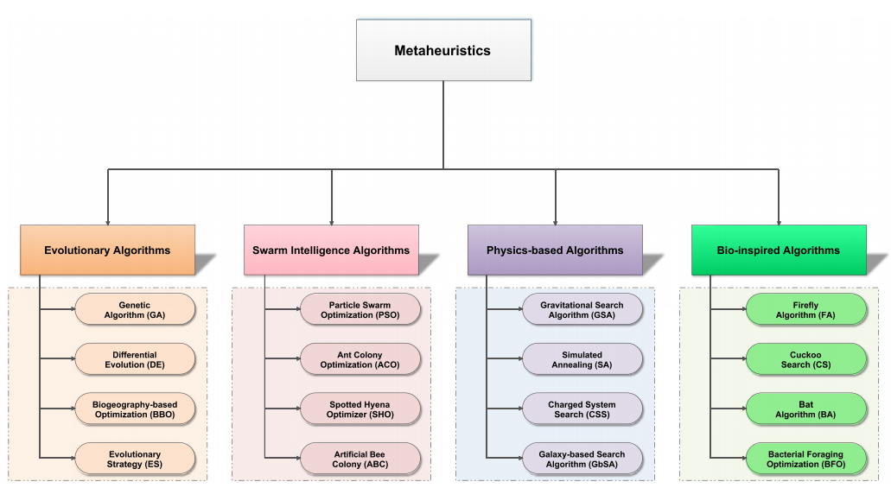
One Enter, 8 pt.
Figure 1. Classification of metaheuristcs. (Figure caption10 pt., centered, resolution should be at least 300 dpi or figure must be clearly visible)
First Enter (10 pt.)
Second Enter (10 pt.)

3. Third Heading (12 pt. Upper and Lower Case Bold and Justify)
Text should be 11 pt. and justify. All tables should be cited in the text.
First Enter (11 pt.)
Second Enter (11 pt.)
Table 1. CTMC model parameters (per hour). (Caption 10 pt. centered; text inside table-8 pt. centered (in case of numeric value), justify (in case of text))
One Enter, 8 pt
Rate | λ_{gd} | λ_{df} | λ_{gf} | ρ_{gf} | ρ_{gv} | Ρ_{vf} | μ_{dg} | r_{vg} | r_{fg}
Set a | 0.00015 | 0.0003 | 0.000018 | 0.00019 | 0.00091 | 0.037 | 0.2 | 0.16 | 0.057
Set b | 0.00015 | 0.0003 | 0.000018 | 0.00019 | 0.0048 | 0.037 | 0.2 | 0.16 | 0.057
Set c | 0.00015 | 0.0003 | 0.000018 | 0.00019 | 0.0136 | 0.037 | 0.2 | 0.16 | 0.057
Set d | 0.00015 | 0.0003 | 0.000018 | 0.00019 | 0.167 | 0.037 | 0.2 | 0.16 | 0.057
Set e | 0.00015 | 0.0003 | 0.000018 | 0.00019 | 3.1 | 0.037 | 0.2 | 0.16 | 0.057
Set f | 0.00015 | 0.0003 | 0.000018 | 0.00019 | 0.0048 | 0.037 | 0.2 | 0.0011 | 0.057
Set g | 0.00015 | 0.0003 | 0.000018 | 0.00019 | 0.0048 | 0.037 | 0.2 | 6.1 | 0.057
Set h | 0.00015 | 0.0003 | 0.000018 | 0.00019 | 0.0048 | 0.037 | 0.2 | 77 | 0.057
Set i | 0.00015 | 0.0003 | 0.000018 | 0.00019 | 0.0048 | 0.037 | 0.2 | 0.16 | 0.000027
Set j | 0.00015 | 0.0003 | 0.000018 | 0.00019 | 0.0048 | 0.037 | 0.2 | 0.16 | 0.68
Set k | 0.00015 | 0.0003 | 0.000018 | 0.00019 | 0.0048 | 0.037 | 0.2 | 0.16 | 74.9
First Enter (8 pt.)
Second Enter (8 pt.)

4. Fourth Heading (12 pt. Upper and Lower Case Bold and Justify)
Text should be 11 pt. and justify.
One Enter (11 pt.)

5. Fifth Heading (12 pt. Upper and Lower Case Bold and Justify)
Text should be 11 pt. and justify.
First Enter (11 pt.)
Second Enter (11 pt.)
Conflict of Interest (9 pt., Left Align)
The authors confirm that there is no conflict of interest to declare for this publication. (9 pt., Justify)
One Enter (9 pt.)
Acknowledgments (9 pt., Left Align)
This research did not receive any specific grant from funding agencies in the public, commercial, or not-for-profit sectors. The authors would like to thank the editor and anonymous reviewers for their comments that help improve the quality of this work. (9 pt., Justify)
First Enter (9 pt.)
Second Enter (9 pt.)
Third Enter (9 pt.)

References (12 pt. Upper and Lower Case Bold and Justify)
All references in APA style and must be cited in text. Size of all references should be 10pt. Line Spacing: Single, Spacing: Before: 6 pt., After: 6 pt.
References must be complete. If possible, include the doi of each article.

